Building an “Inexfensive” Box

Bacil Shaqqo  
Matthew Schnur

Introduction

This build guides give an overview and tips on how to construct an inexfensive scoring box. This guide does not repeat any of the information listed in the datasheets, so those will need to be consulted. There is a comprehensive parts list with part numbers and vendors listed, so finding those datasheets is made easy. The guide is laid out as follows.

* General Architecture
* Required Parts
* Arduino Uno Circuit
* Piezo Buzzer Circuit
* LED arrays
* Score Display
* Timer
* IR Receiver and Additional Displays
* General Construction

General Architecture

The fencing box is built out of modular components as shown below. A basic description of each of the components is listed in the table below the diagram. The circuits will be presented in the order as follows.

Arduino Uno Circuit

Fencer B

Fencer A

Arduino Mega Circuit

1

2

3

4

5

6

7

8

Score

Score

Timer

Weapon Select Switch

IR Receiver

Left LED Array

Right LED Array

Piezo Circuit

|  |  |
| --- | --- |
| **Component** | **Description** |
| Arduino Uno | Monitors the fencers and reports state changes to the Arduino Mega |
| Arduino Mega | Controls all display devices |
| Piezo Circuit | Piezo buzzer and power control switch to provide audible indication of touch |
| LED Arrays | Large bright LEDS that indicate different events through different colors |
| IR Receiver | IR receiver chip that can interpret commands from remote |
| Scoreboard | Very large 7-segment displays to indicate scores of fencers – Needs Remote Control |
| Timer | Medium 7-segment displays to indicate time remaining in bout – Needs Remote Control |

|  |  |  |  |  |  |
| --- | --- | --- | --- | --- | --- |
| **Vendor** | **Manufacturer Part Number** | **Quantity** | **Price** | **Total Price** | **Description** |
| Digikey | CD74HC4511E | 10 | $0.70 | $7.00 | 7 segment display driver |
| Digikey | LM317AT/NOPB | 5 | $1.62 | $8.10 | voltage regulator |
| Mouser | A000067 | 1 | $45.95 | $45.95 | Arduino Mega |
| Mouser | A000066 | 1 | $24.51 | $24.51 | Arduino Uno |
| Mouser | C513A-WSS-CY0Z0341 | 50 | $0.30 | $15.00 | White LEDs |
| Mouser | C503B-ACN-CY0Z0341-030 | 20 | $0.14 | $2.80 | Amber LEDs |
| Mouser | C503B-GCN-CY0C0792 | 30 | $0.26 | $7.80 | Green LEDs |
| Mouser | SA23-11SRWA | 5 | $4.19 | $20.95 | Medium 7 Segment Displays |
| Digikey | PPTC052LJBN-RC | 3 | $1.33 | $3.99 | Internal Connector Header |
| Digikey | PPPC122LJBN-RC | 2 | $2.12 | $4.24 | Internal Connector Header |
| Digikey | PPTC042LJBN-RC | 3 | $1.20 | $3.60 | Internal Connector Header |
| Digikey | 22284360 | 5 | $0.95 | $4.75 | Internal Connector Header |
| Mouser | SA15-11GWA | 5 | $2.93 | $14.65 | Large 7 Segment Displays |
| Digikey | GRSV-4021-0006 | 1 | $1.47 | $1.47 | On/Off Switch |
| Mouser | PLD-27A35WQ | 1 | $10.54 | $10.54 | Piezo Buzzer |
| Digikey | RP3502ABLK | 2 | $1.80 | $3.60 | Weapon Selection Button |
| Digikey | 100SP1T1B1M1QEH | 2 | $2.11 | $4.22 | Volume Selection Switch |
| Digikey | J152-ND | 2 | $0.70 | $1.40 | Black Female Socket |
| Digikey | J151-ND | 8 | $0.70 | $5.60 | Red Female Socket |
| Digikey | H247-ND | 10 | $0.16 | $1.60 | Locking Washer |
| Amazon | B00KB3RB3U | 1 | $7.97 | $7.97 | Universal Remote |
| Amazon | B0023Y9EQC | 1 | $7.22 | $7.22 | 12V DC Power Supply |
| Home Depot | n/a | 1 | $6.57 | $6.57 | Wood |
| Lowes | n/a | 1 | $21.98 | $21.98 | Plexiglass |
| Lowes | n/a | 4 | $2.33 | $9.32 | Wood |
| Amazon | B013ZWM1F6 | 1 | $27.99 | $27.99 | Screws & Standoffs |
| Digikey | C503B-RCS-CW0Z0AA1 | 35 | $0.14 | $4.94 | Red LEDs |
| Digikey | ULN2003A | 10 | $0.43 | $4.31 | Transistor Arrays |
| Digikey | TSOP4856 | 2 | $1.33 | $2.66 | IR Receiver |
| **Total** |  |  |  | **$284.73** |  |

Components list and pricing

Arduino Uno Circuit

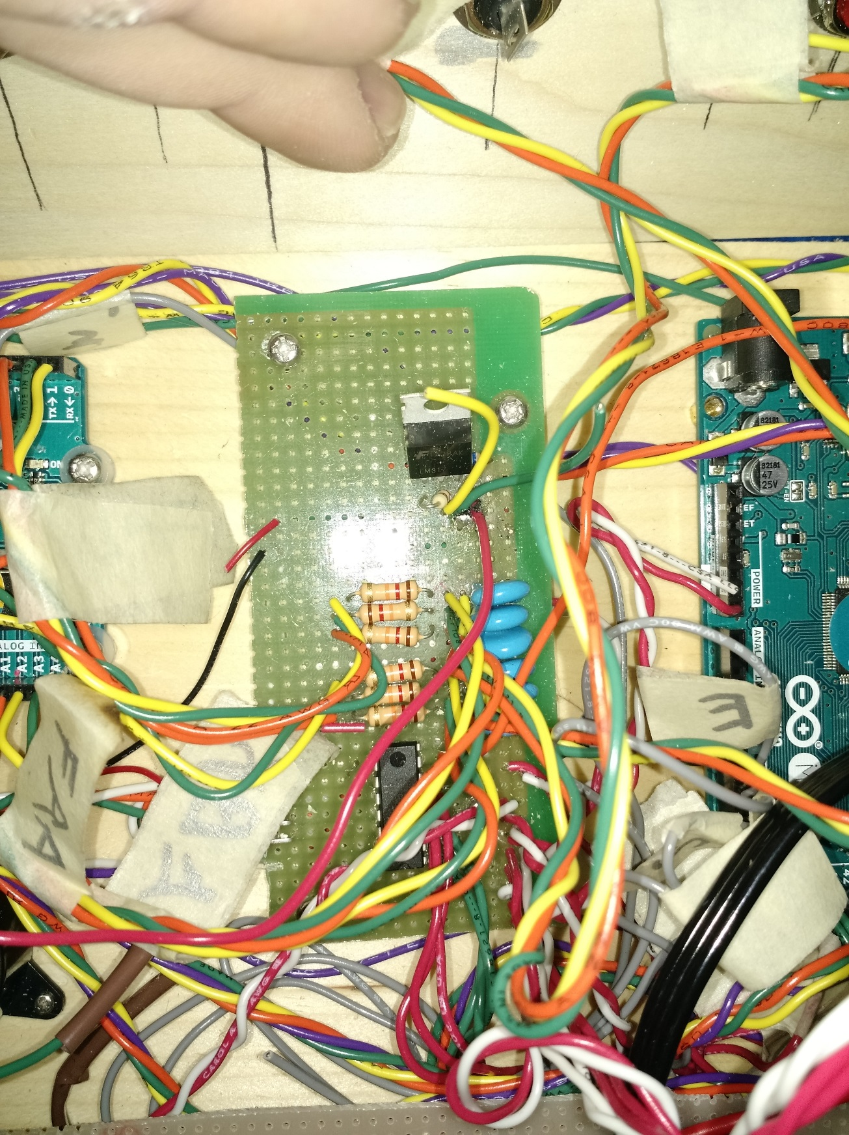

Regulator for piezo volume control

Resistors and capacitors shown in circuit

Transistor array for piezo and LED arrays

Wires to Arduino

Leads to volume control switch

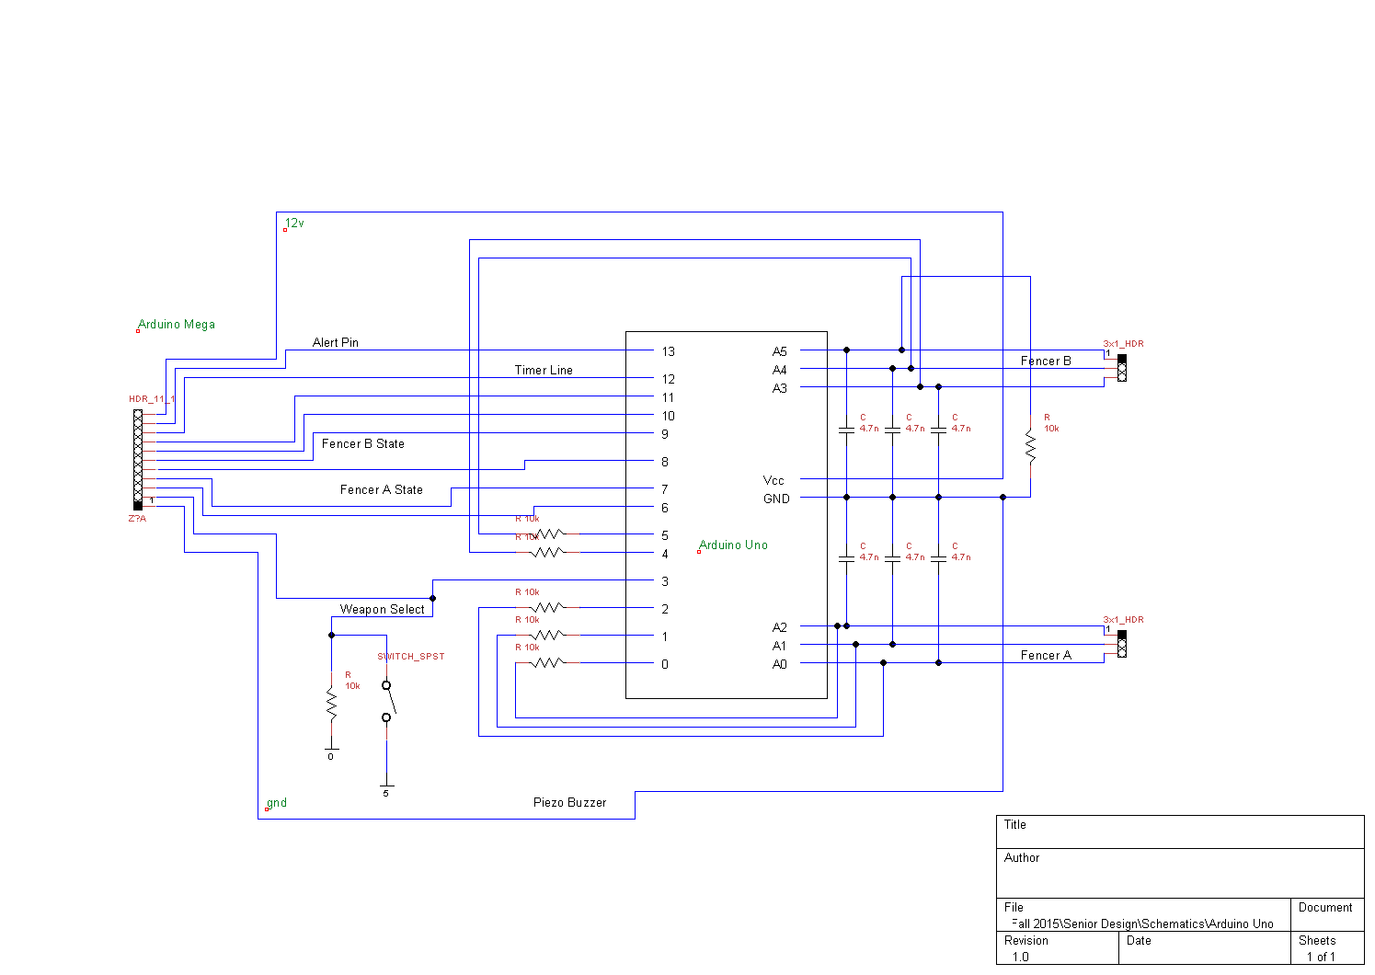

This circuit serves as the core of the device. This is the only component that was “hardwired” into the system because it is essential for operation. For space reasons, the weapon select switch is not included on this board because it is already very busy. It is shown later on the timer board. Furthermore, the board contains a transistor array. Furthermore, the volume control switch shown on the piezo circuit is connected to this board. This transistor array operates both the piezo and the LED arrays.

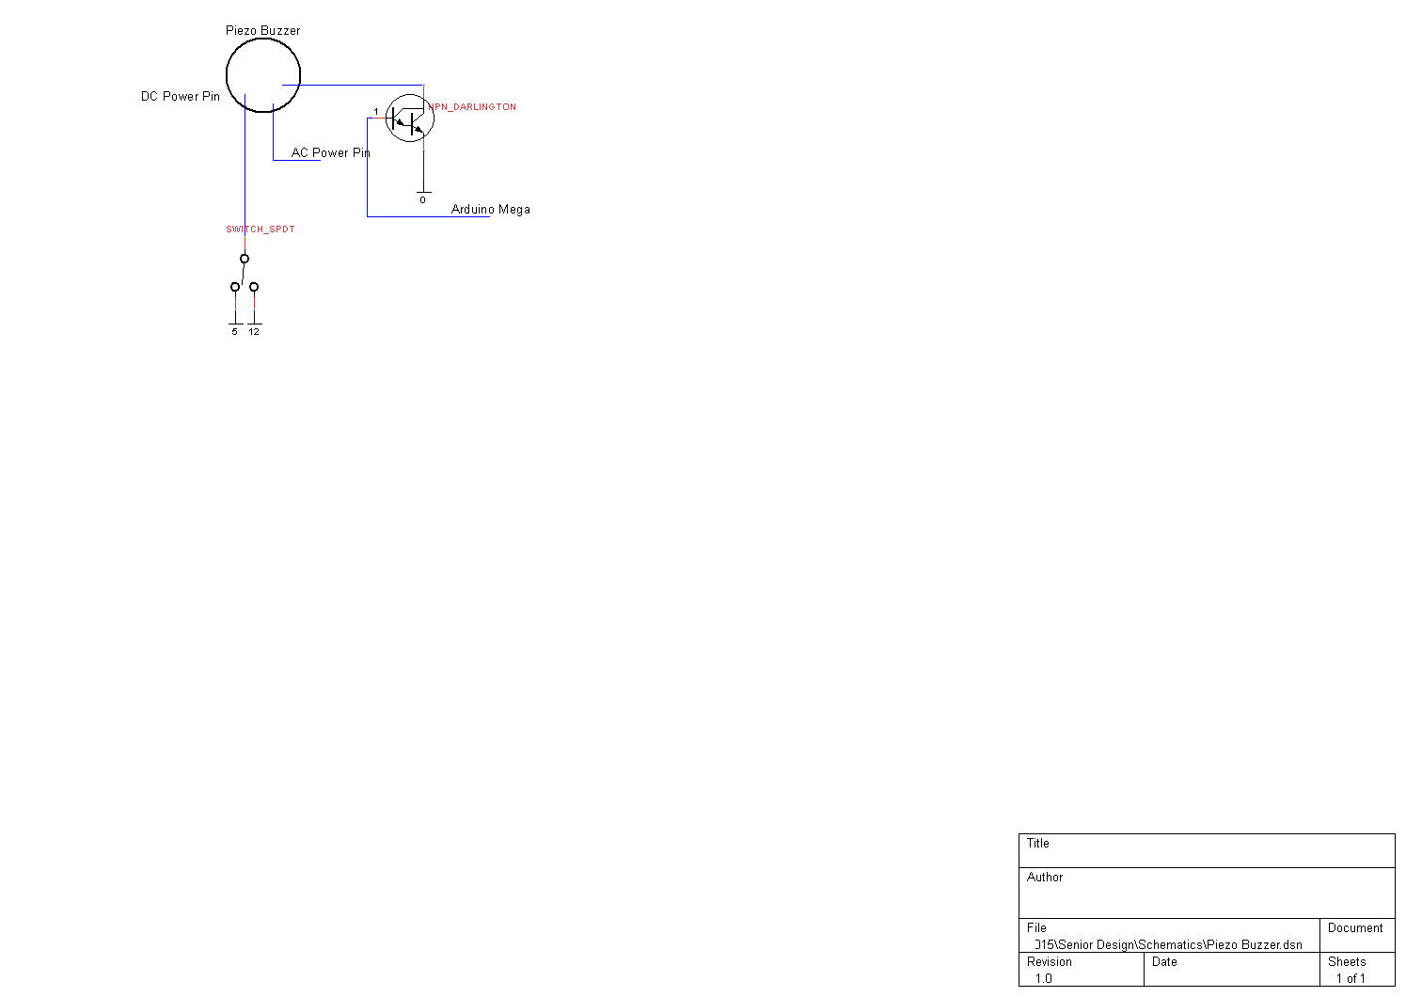Piezo Circuit

The Piezo buzzer we selected can be driven by AC or DC. We are controlling it with a DC signal, so the blue AC line can be ignored. Notice that the red power line goes to the middle of the single pull double throw (SPDT) switch. You can choose other voltages in terms of volume, but 5 and 12 was easy to do, and provided a nice range. The NPN Darlington transistor shown is one of the transistors in the array.

With some LEDs connected to the state lines, and this piezo buzzer, the box will produce audio visual signals scoring a touch. The following sections describe additional peripherals.

Initially, the Arduino Mega is described. There is no circuit diagram of the mega, only a pinout table. The mega operates as a large display driver.

### Arduino Mega

1

2

3

4

5

6

7

8

Score

Score

Timer

The Arduino Mega drives all of the output display features of the device and receives inputs from the Arduino Uno, as can be seen in the Arduino Uno circuit. However, this device itself requires no actual support circuity. As such a diagram does present any significance. A pinout of the device is below. It lists all pin numbers that supporting circuitry will be attached to in the Arduino Mega as well as a repeat of the diagram of all the digits that will be used.

|  |  |  |  |  |  |
| --- | --- | --- | --- | --- | --- |
| Pin | Description | Input/Output | Pin | Description | Input/Output |
| **0** |  |  | **27** | Digit 3.C | Output |
| **1** |  |  | **28** | Digit 3.B | Output |
| **2** | Weapon Mode Change | Input/Output | **29** | Digit 3.A | Output |
| **3** | Uno State Change | Input | **30** | Digit 1.D | Output |
| **4** |  |  | **31** | Digit 1.C | Output |
| **5** | Piezo Buzzer | Output | **32** | Digit 1.B | Output |
| **6** | Time Remaining | Output | **33** | Digit 1.A | Output |
| **7** | FB On Target (From Uno) | Output | **34** | Digit 2.D | Output |
| **8** | FB Off Target (From Uno) | Output | **35** | Digit 2.C | Output |
| **9** | FB Off Target (From Uno) | Output | **36** | Digit 2.B | Output |
| **10** |  |  | **37** | Digit 2.A | Output |
| **11** | FA On Target (From Uno) | Output | **38** | Digit 7.D | Output |
| **12** | FA Off Target (From Uno) | Output | **39** | Digit 7.C | Output |
| **13** | FA Self Contact (From Uno) | Output | **40** | Digit 7.B | Output |
| **14** | Digit 6.D | Output | **41** | Digit 7.A | Output |
| **15** | Digit 6.C | Output | **42** | Digit 8.D | Output |
| **16** | Digit 6.B | Output | **43** | Digit 8.C | Output |
| **17** | Digit 6.A | Output | **44** | Digit 8.B | Output |
| **18** | Digit 5.D | Output | **45** | Digit 8.A | Output |
| **19** | Digit 5.C | Output | **46** | FB Green LEDs | Output |
| **20** | Digit 5.B | Output | **47** | FB White LEDs | Output |
| **21** | Digit 5.A | Output | **48** | FB Yellow LEDs | Output |
| **22** | Digit 4.D | Output | **49** | FA Red LEDs | Output |
| **23** | Digit 4.C | Output | **50** | FA White LEDs | Output |
| **24** | Digit 4.B | Output | **51** | FA Yellow LEDs | Output |
| **25** | Digit 4.A | Output | **52** | IR Receiver | Input |
| **26** | Digit 3.D | Output | **53** |  |  |
| Analog Pins | | | | | |
| **A8** | Épée Light | Output | **A10** | Sabre Light | Output |
| **A9** | Foil Light | Output |  |  |  |

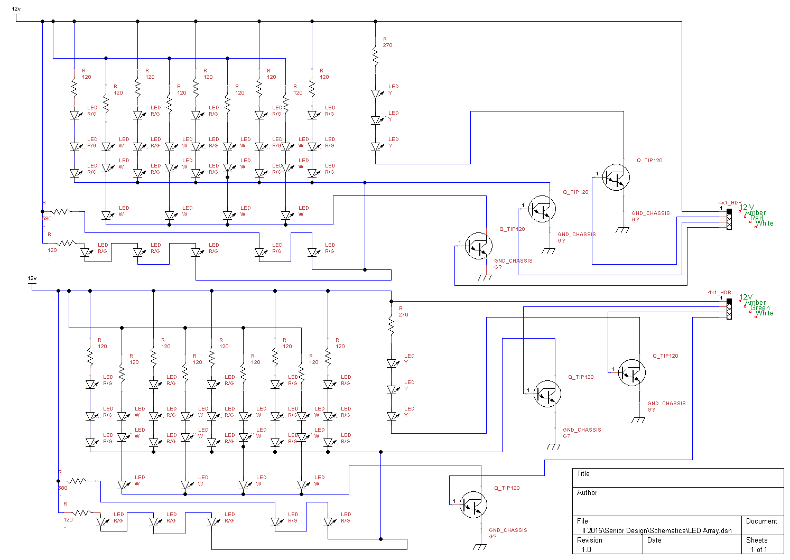The first and easiest components to hook up are the LED arrays. There are four kinds of LEDs required as can be seen on the parts list. Resistor values were selected to get a good amount of brightness out of these LEDs and still keep them well below tolerance. For the white, green and red LEDs, 120Ω resistors were used. 270Ω resistors were used for the amber LEDs because they have a smaller voltage drop. There is an instance where there are only two series LEDs exist. A 580Ω resistor equalizes the current and therefore brightness

A picture of the LED described above is below:

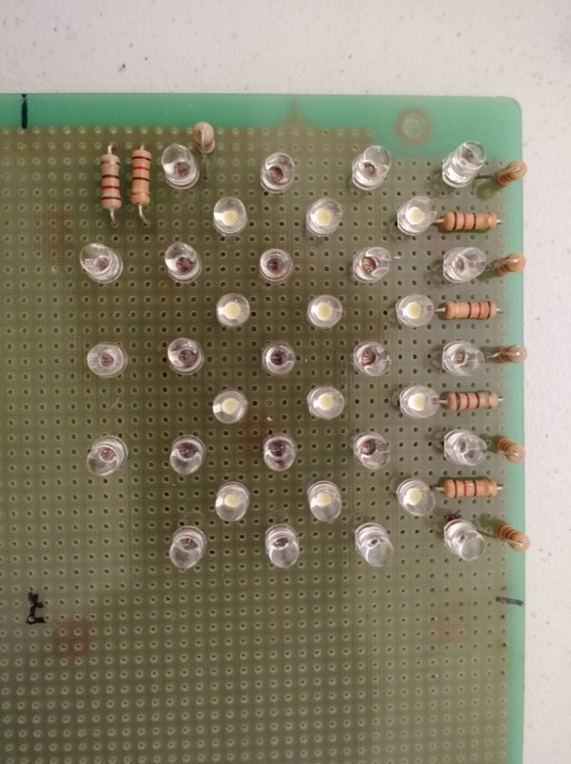

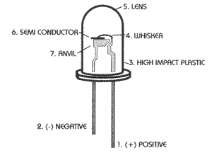Headers were ultimately attached and used to route the cables to the Arduino Uno circuit board. The LEDs selected are clear, but color of light they give off is represented by the colored circle. By placing the resistors before each LED string, the circuit was made neater. Because the transistors arrays are used, there are only four inputs necessary: 12v and a ground for each color. When the transistor is activated, it connects the ground lines to actual ground, which causes the LEDs to turn on.

While it appears that the LEDs are connected in rows of four and three respectively, they are actually in batches of three and a single batch of two. This is because no more than three LEDs could be placed in a row and still attain sufficient brightness. The connections of the LEDs can be seen in the circuit diagram or the below image. Each series of LEDs has its own resistor.

The leads attached to the LEDs can be used to connect them without additional wire. Note that every LED has two leads. The longer lead is always the positive terminal. This can be seen on the diagram to the left. If the leads have been cut, the diagram to the left can also be used. The high impact plastic side (with less metal) is the positive terminal.

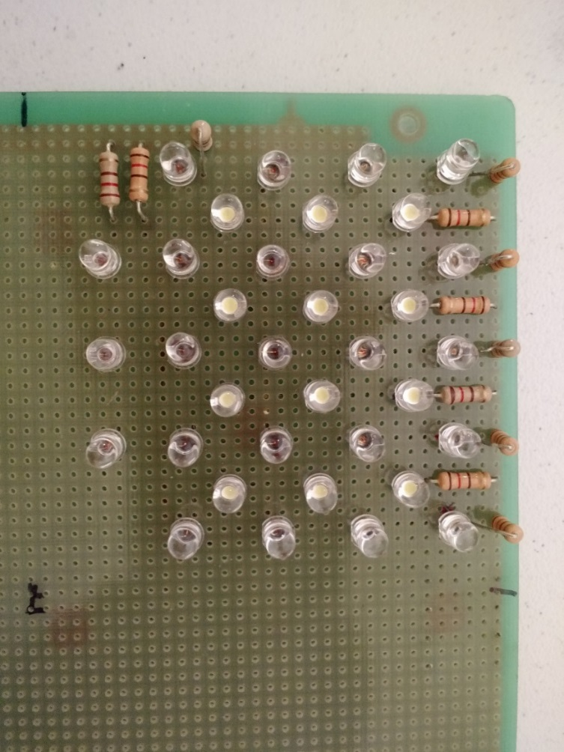

**Score Display**

Decoder

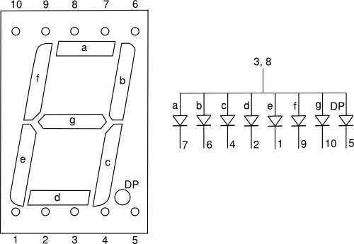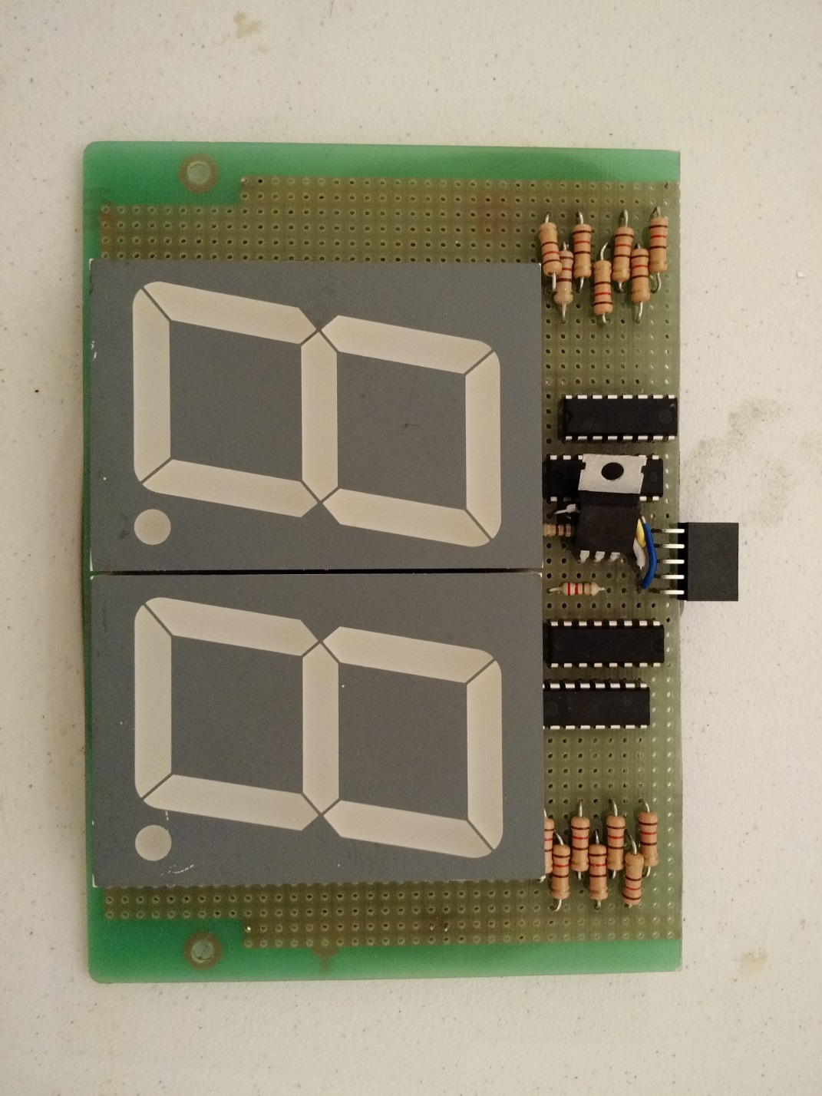One of the two score display boards is shown to the right. Each module includes two digits. The only shared hardware between the two digits is the 5v regulator that is used to power the decoders. Note that the displays are common anode, and not common cathode. Furthermore, the decoders can’t operate at the voltage necessary to drive the displays. The transistor arrays were therefore necessary.

Current Limiting Resistors

(120Ω)

Transistor Array

Regulator

Digit

By placing the transistors next to the decoders and shifted by one space allows the use of solder bridges to directly connect the pins of the decoder to the transistor array. Furthermore, it is best to have the outputs of the transistors facing towards the edge of the board. Therefore, placing the left set of components upside down is preferable because it prevents congestion in the center. Some of the pins on the decodes need to be tied to either high or 5v. Do not connect any portion of the A pinout of the display is not provided on the accompanying datasheet, so one is provided below.

Seven Segment Display Pinout

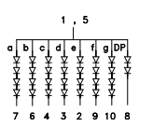

This pinout is extremely helpful for building the scoreboard and timer modules. The circuit diagram for these devices is shown on the following page.

Seven Segment Display Digit Circuit Diagram

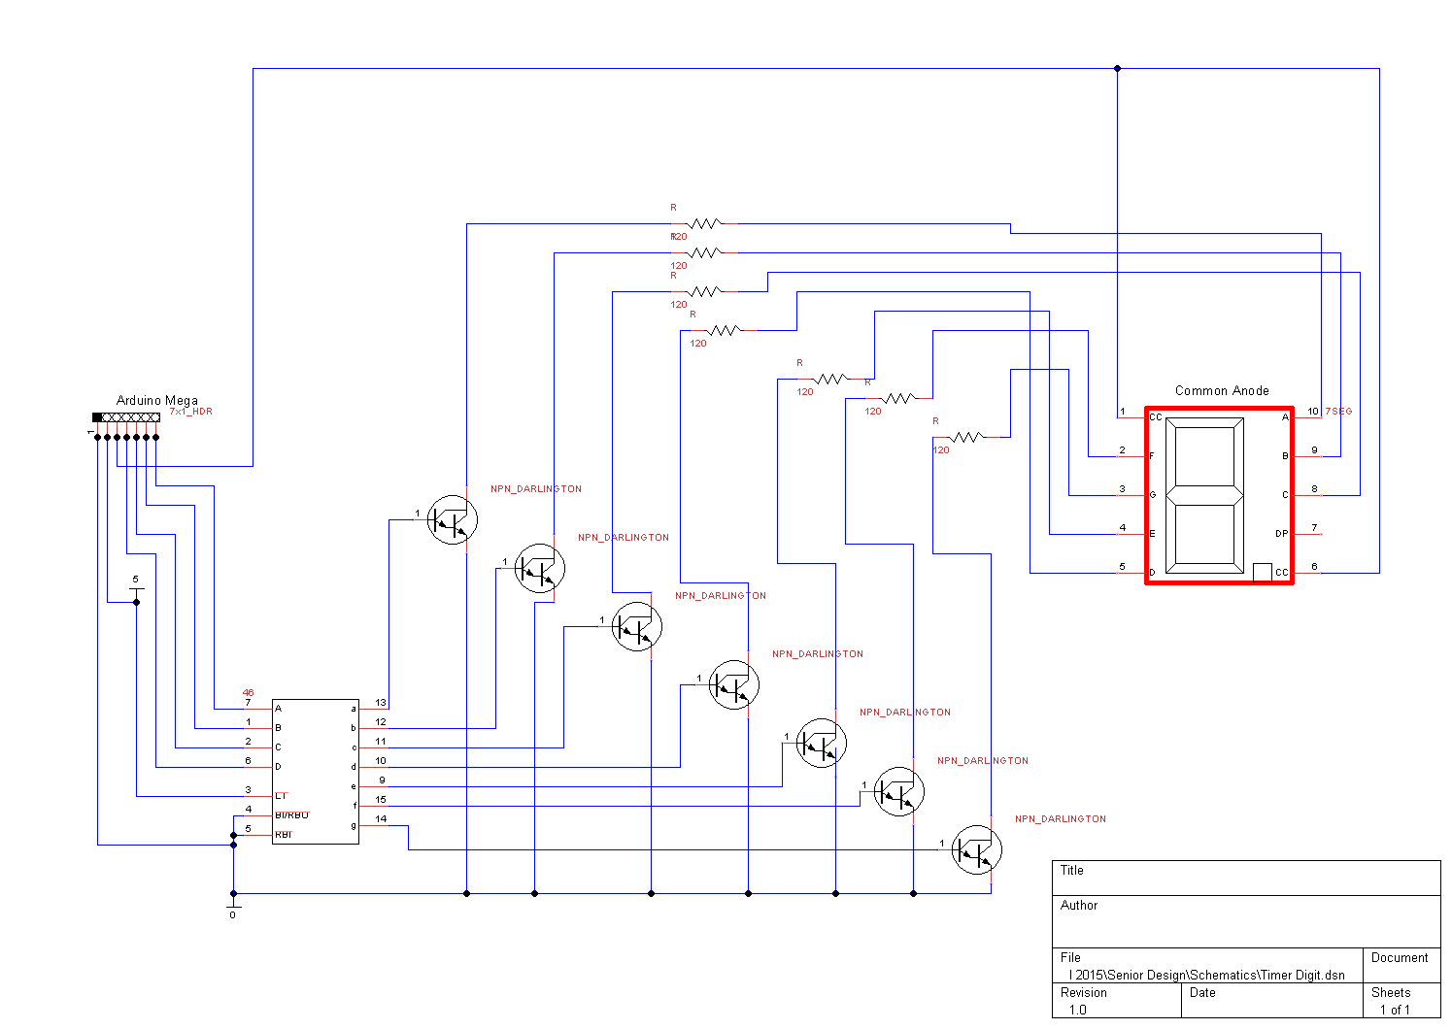

The below image is the completed timer. Notice that the same transistors and decoders were used as in the score display. Only one regulator is necessary to run all of the decoders. It was placed off to the side for special reasons. The 5 volts produced from that regulator can also be used to power two LEDs that represent the colon purely for cosmetic purposes. The perf board used here had additional space above the decoders, so the weapon select light, the IR receiver and a header used for the weapon select switch were placed above.

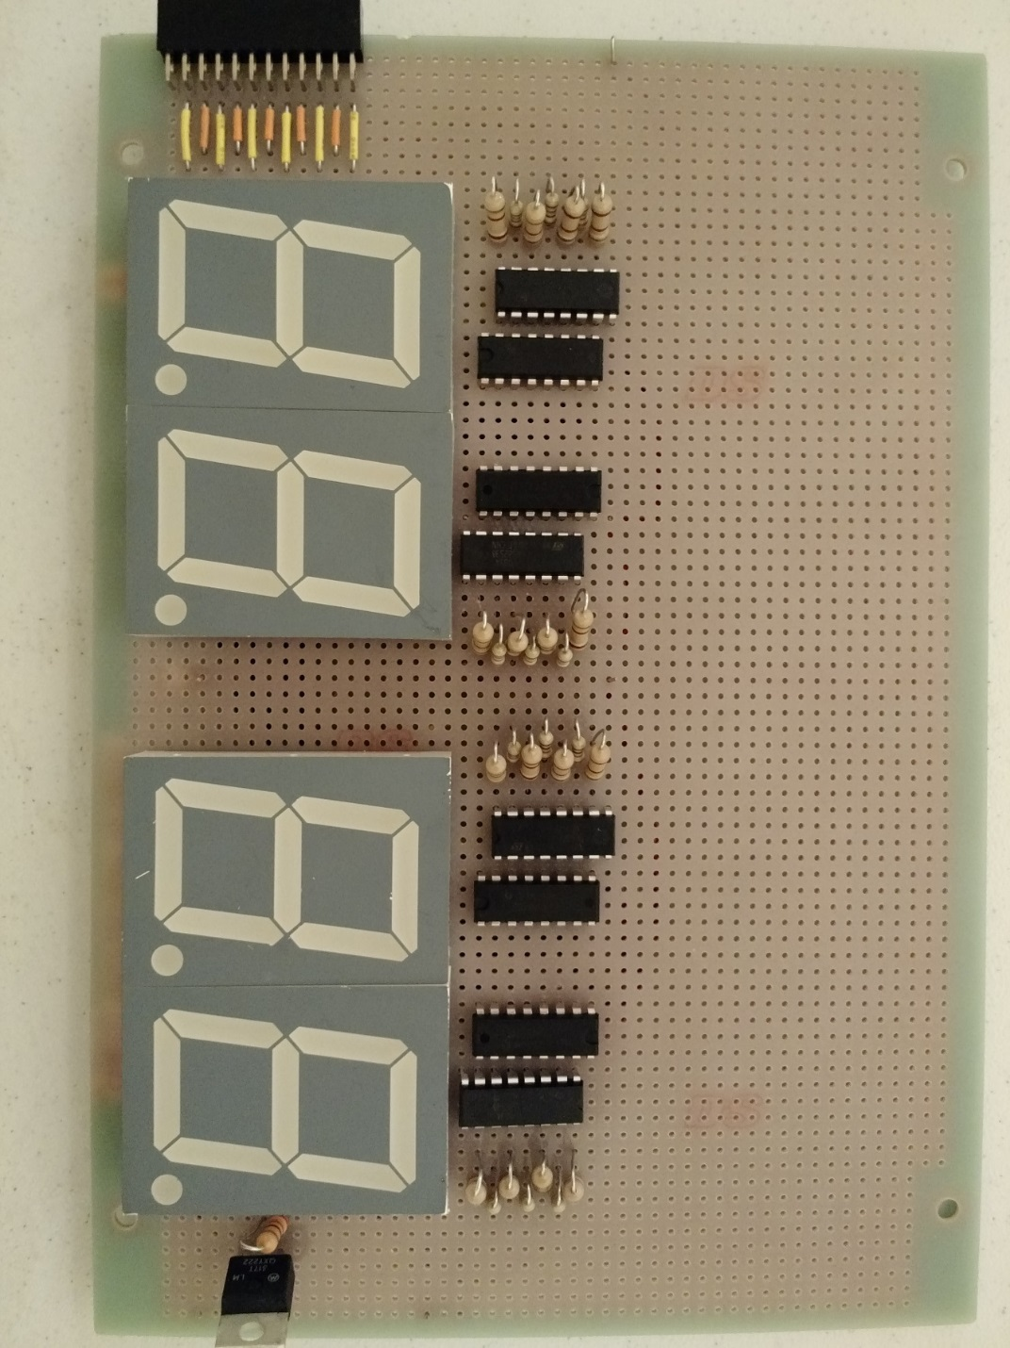

The IR Receiver only needs to connect to the Arduino Mega, 5V and ground. The LEDs need to be attached to the appropriate GPIO pins and give a current limiting resistor. If using the LEDs we suggested, large resistors are necessary (~2.7kΩ) to prevent the LED from being too bright. The header for weapon select switch is not entirely necessary. We used it so the front of the casing could be easily detached without damaging the wiring.

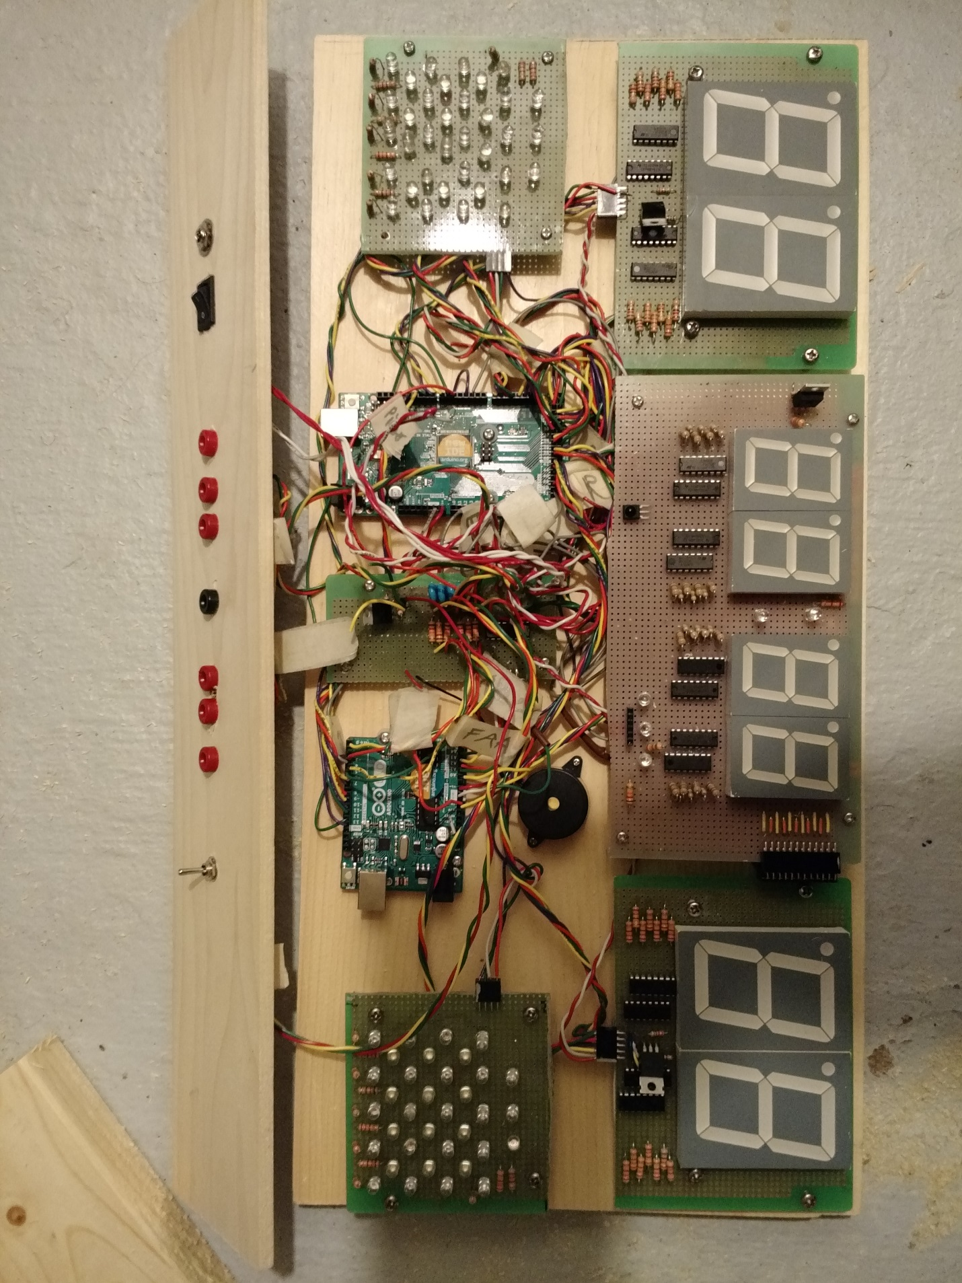General Construction

Ultimately, the entire end project as laid out like this:

Our end goal involves making a box around the design and putting Plexiglas on the front. Additional holes were drilled in the perf boards, and standoffs were used to elevate the components away from the mounting board. The standoffs also let us run wires beneath the boards, which reduced (but not solved) the congestion problem. Note that while there are many wires, none are routed over any of the display components. All of the jacks and switches are on the top and not on the Plexiglas because Plexiglas is more risky to drill through. A better image of the top is on the next page.  
  
The inputs and outputs of the system are below. It is recommended to use a reliable Epee Cable or floor cord to measure the spacing of the holes relative from each other. It is also recommended to double check power jack outputs to make sure the correct terminals are connected.

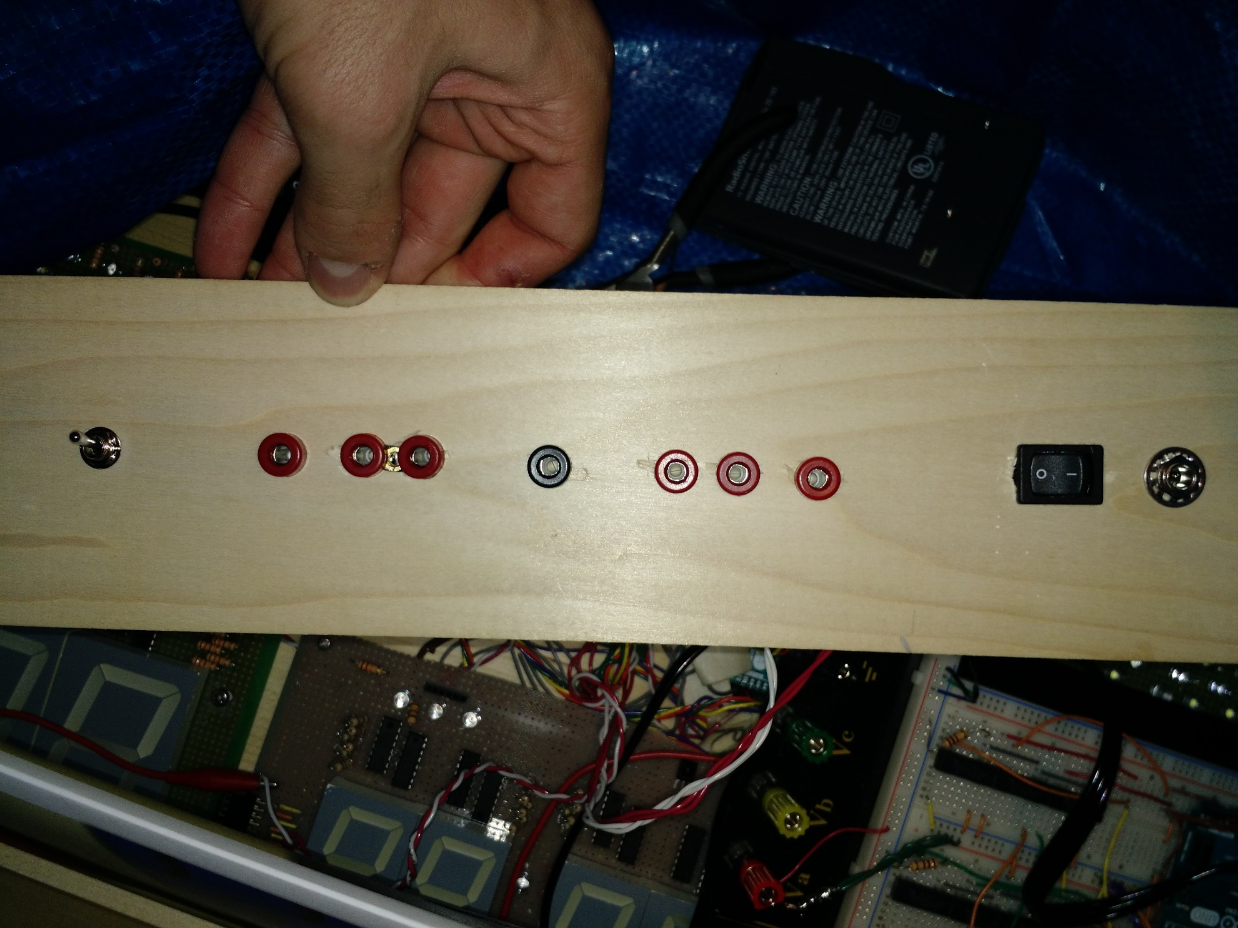

Fencer A

Fencer B

Piste

Volume Control

Power Switch

Power Jack